|  |  |
| --- | --- |
| **SQL Lab Practice - 1** |  |
|  | http://www.lsp4you.com/images/goldline.gif |  |
|  | **Create the following tables** |  |
| Table - I ( CLIENT_MASTER ) | | |
| |  |  |  |  |  | | --- | --- | --- | --- | --- | | **Data for Client_Master** | | | | | | **Client_No** | **Name** | **City** | **Pincode** | **Bal_due** | | C00001 | SMITHA JAIN | Mumbai | 400054 | 15000 | | C00002 | VANDANA  RAO | Chennai | 780001 | 0 | | C00003 | PREM PUJARI | Mumbai | 400057 | 5000 | | C00004 | BASU NATH | Mumbai | 400056 | 0 | | C00005 | RAVI SHANKAR | Delhi | 100001 | 2000 | | C00006 | ROOPA | Mumbai | 400050 | 0 | | | |
| Table - II ( SALE_ORDER ) | | |
| |  |  |  |  |  |  | | --- | --- | --- | --- | --- | --- | | **Data for Sale_Order** | | | | | | | **Order_No** | **Order_Date** | **Client_No** | **Salesman_No** | **Dely_Date** | **Order_Status** | | O19001 | 12-Jan-13 | C00001 | S00001 | 20-Jan-13 | In process | | O19002 | 25-Jan-13 | C00002 | S00002 | 27-Jan-13 | Cancelled | | O46865 | 18-Feb-13 | C00003 | S00003 | 20-Feb-13 | Fulfilled | | O19003 | 03-Apr-13 | C00001 | S00001 | 07-Apr-13 | Fulfilled | | O46866 | 20-May-13 | C00004 | S00002 | 07-Apr-13 | Cancelled | | O19008 | 24-May-13 | C00005 | S00004 | 26-May-13 | In process | | | |
| **Write SQL commands for the following:** | | |
| **1.** | **List all details from the client_master table for clients whose Bal_due = 0.** | |
| **2.** | **Update table client_master, Change city of Client_no C00004 to Jaipur.** | |
| **3.** | **Retrieve records of clients residing in Mumbai.** | |
| **4.** | **Find the name and address of customer who has placed Order_no 'O19003' and 'O19002' respectively.** | |
| **5.** | **Construct English like sentence from the table client_master ({Customer name} live in the city of {city}).** | |
| **6.** | **List the client_no, name, city and pincode of clients whose Order_status is "In process".** | |

# Answers:

1. First table creation and first 3 commands are performed

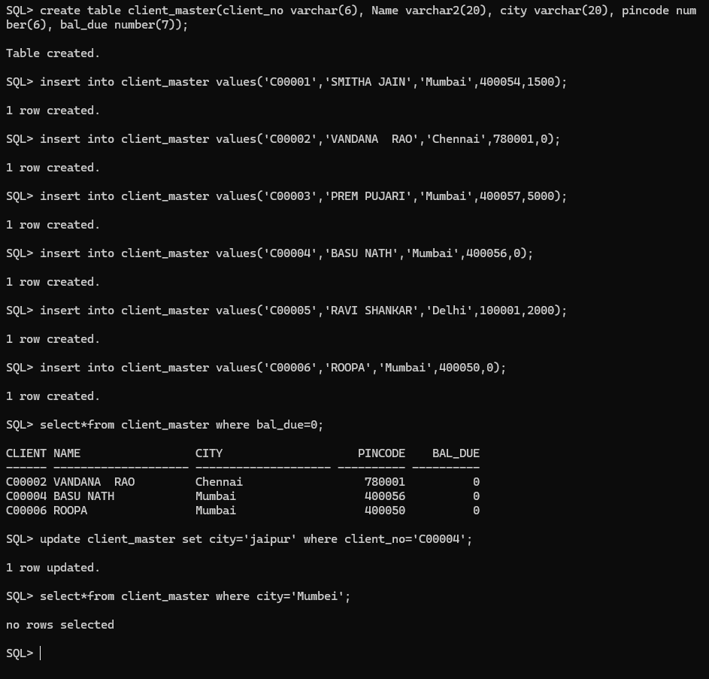

2.table creation

